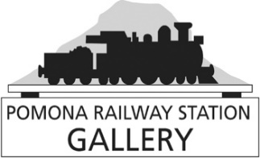
ART MARKET IN THE PADDOCK

Saturday 4rd May

CONDITIONS AND REGISTRATION FORM

CONDITIONS OF ENTRY:

- Registration fee is $30 per artist or $50 for a group of 2 or more Artists.
- All items for sale must be crafted by the Artist or Group.
- Exhibitors are to provide their own display methods i.e. shelter, stands, easel, table or tarps. The area occupied should not exceed 3m X 3m.
- Art Market hours: 9:00am to 1:00pm
- Exhibitors are to start setting up by 7:30am
- No commission will be taken by the Gallery on sales
- Stall holders are to clean up their area before leaving the site
___________________________________________________________________

Please complete the following information and return by 28th April 2024
Artist Name (Principal contact): _________________________________________

Telephone Number: ___________________________________________________

Email address: _______________________________________________________

TYPE OF WORK FOR SALE: eg: Craft, paintings, ceramics, woodwork, photography etc.

___________________________________________________________________

If paying by Direct Debit: BSB: 633 000 Account: 171600125 (as a reference, please use your surname +”AM” (art market) so we can identify the payment)

In Person: Deliver form and payment of $30 per artist or $50 for a group of 2 or more to the gallery .

Office Use

Registration accepted by (gallery staff name): ______________________

FEE PAID? YES NO (circle one) Date received: ______________________

Thank you for your application

Email: pomonagallery@gmail.com Website: www.pomonartgallery.com

